**UNIVERSITY OF ENERGY AND NATURAL RESOURCES, SUNYANI**



**SCHOOL OF SCIENCE**

**DEPARTMENT OF INFORMATION TECHNOLOGY AND DECISION SCIENCES**

**LEVEL 400 “A”**

**GROUP 5 MEMBERS**

|  |  |
| --- | --- |
| **ADAMAH NII ARMAH EDWIN** | **UEB3206220** |
| **ALHASSAN MUKARAMA(Ms)** | **UEB3214520** |
| **APPIAH GLORIA YEBOAH(Ms)** | **UEB3216420** |
| **CHANASE WEWURA LAZARUS** | **UEB3267922** |
| **HENYO REJOICE(Ms)** | **UEB3220320** |
| **LARH STEPHEN** | **UEB3206020** |
| **NKETIAH EMMANUEL YEBOAH** | **UEB3210220** |
| **OPOKU AMPONG BETTYE(Ms)** | **UEB3211320** |
| **OWUSU RICHARD** | **UEB3208320** |
| **UCHE UGOCHUKWU SUCCESS** | **UEB3203120** |

**A DOCUMENTATION ON THE ERP’S SYSTEM ARCHITECTURE, MODULES AND FUNCTIONALITIES**

**Table of Contents**

1.Introduction

1.1 System Architecture

2.1 Overview

2.2 Technological Requirements

3. Modules and Functionalities

3.1 Inventory Management

3.2 Production Planning and Control

3.3 Sales and Order Processing

3.4 Purchasing and Supplier Management

3.5 Finance and Accounting

3.6 Human Resources Management

3.7 Reporting and Analytics

4. Security Architecture

5. Scalability and Integration

6. User Interface Design

7. Database Design

8. Implementation

8.1 Deployment Phases

8.2 Training Plan

8.3 Support and Maintenance

8.4 Risk Management

9. Conclusion

1. **Introduction**

This is a detailed design document for a comprehensive ERP system for Mini manufacturing company. It provides information about the system architecture, core modules with their corresponding purpose for serving the operational administration as well management and analytical needs of the company. An ERP system streamlines core business processes, while improving overall ties and clarity of real-time data on which those businesses base their most notable decisions.

1. **System Architecture**

The system architecture is organized in the conventional client-server approach with a web-based User Interface. The ERP system is design to be modular and scalable, allowing for future growth and additional functionality. The system is categorized into seven main modules: Inventory Management, Production Planning and Control, Sales and Order Processing, Purchase and Supplier Management, Finance and Accounting Human Resources Management and Reporting and Analytics.

**2.1 Technological Requirements**

* **Frontend Development**: HTML, CSS, React.js will be used to design a interactive user interface.
* **Backend Development:** Python with the use of framework Django will be used for server-side processing.
* **Database:** MySQL will be used for the data storage.
* **Middleware:** Integration middleware like REST API will be used for communicating with legacy systems.

1. **Modules and Functionalities**

**3.1 Inventory Management**

The Inventory Management module of the ERP system handles the real-time tracking and management of stock, both raw materials and finished goods.

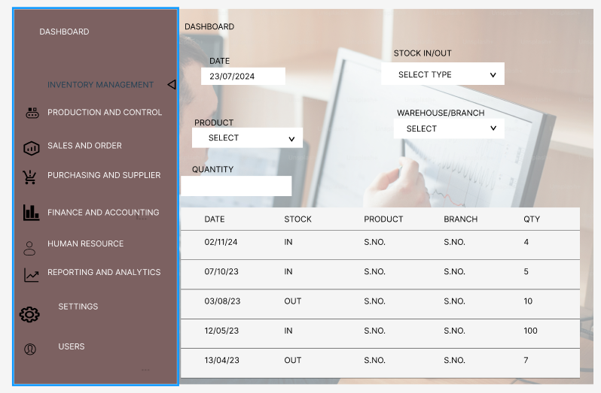

**Key Functionalities:**

Document Generation: Automatically generate purchase orders, stock receipts, and inventory audit reports.

Stock Level Monitoring: Track inventory levels and locations, automate reordering based on minimum thresholds.

Stock Auditing: Generate stock reconciliation reports.

Stock Overview Dashboard: Visual representation of current inventory levels, stock locations, and product categories.

* 1. **Production Planning and Control**

The Production Planning and Control module is responsible for scheduling and monitoring production activities.

**Key Functionalities:**

Work Order Creation: Generate and assign unique work order numbers to production tasks.

Production Scheduling: Manage and allocate resources such as machinery, materials, and labor for each work order.

Progress Monitoring: Real-time tracking of production stages.

Quality Control: Ensure products meet specified quality standards, with quality check logs for each work order.

Document Generation: Produce work orders, production plans, and machine utilization reports.

* 1. **Sales and Order Processing**

The Sales and Order Processing module ensures the efficient handling of customer orders from initiation to fulfillment by streamlining the sales process from capturing orders to delivering products.

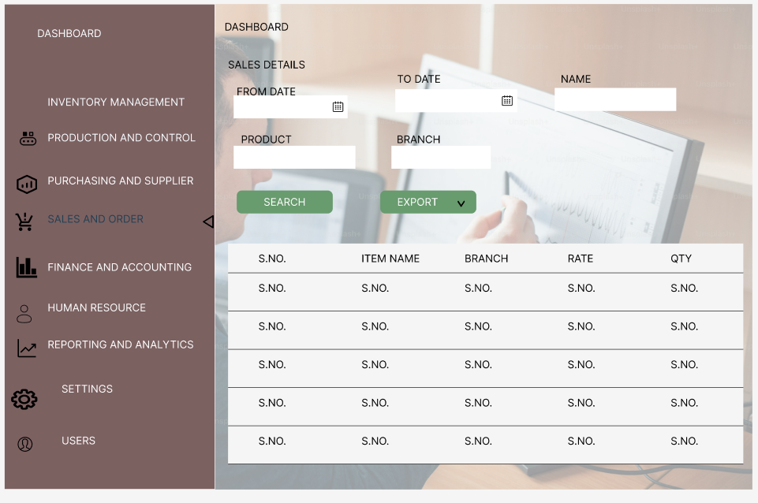

**Key Functionalities:**

Order Entry: Capture customer orders with details such as product, quantity, and delivery instructions.

Order Fulfillment: Track the fulfillment process from order receipt to delivery.

Invoicing: Generate invoices automatically based on completed sales orders.

Customer Relationship Management: Maintain customer details, order history, and contact information.

* 1. **Purchasing and Supplier Management**

The Purchasing and Supplier Management module is designed to handle procurement activities and supplier relationships.

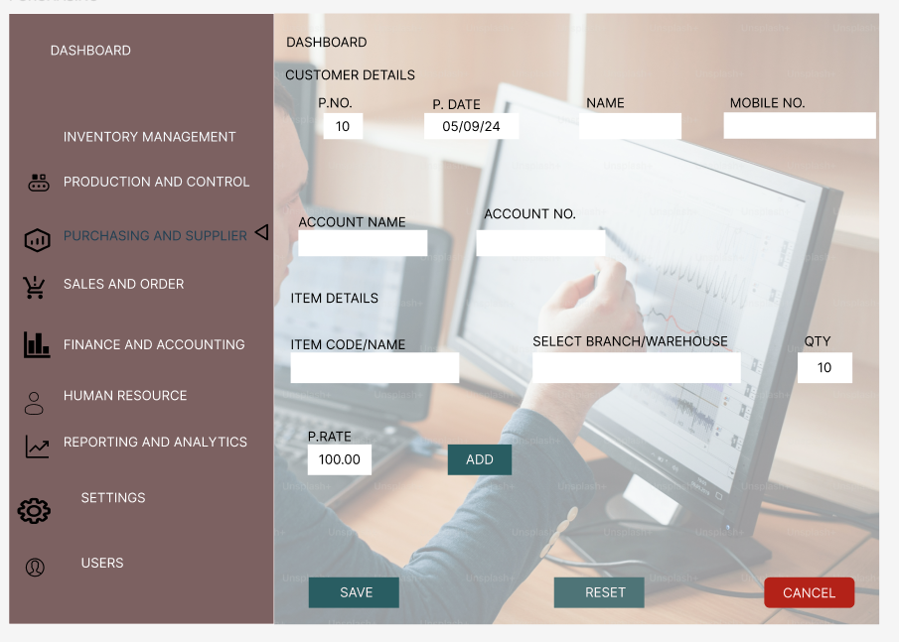

**Key Functionalities:**

Supplier Database: Store and manage supplier information, including contracts and performance ratings.

Purchase Order Management: Create and track purchase orders, manage approvals, and handle supplier communications.

Delivery Tracking: Monitor deliveries against purchase orders.

Document Generation: Automate the creation of purchase orders, delivery receipts, and supplier contracts.

* 1. **Finance and Accounting**

The Finance and Accounting module tracks financial transactions and manages financial reporting.

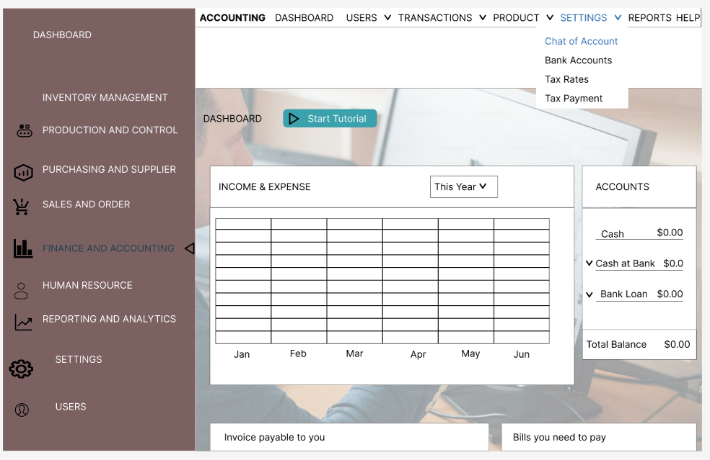

**Key Functionalities:**

Transaction Dashboard: Overview of financial transactions including accounts payable, receivable, and general ledger entries.

General Ledger: Record all financial transactions and automatically update accounting ledgers.

Budgeting and Forecasting: Create and monitor budgets, and forecast future financial performance.

Financial Reporting: Generate balance sheets, income statements, and cash flow reports.

* 1. **Human Resource Management**

The Human Resources Management module is designed to manage employee information, payroll, and performance tracking.

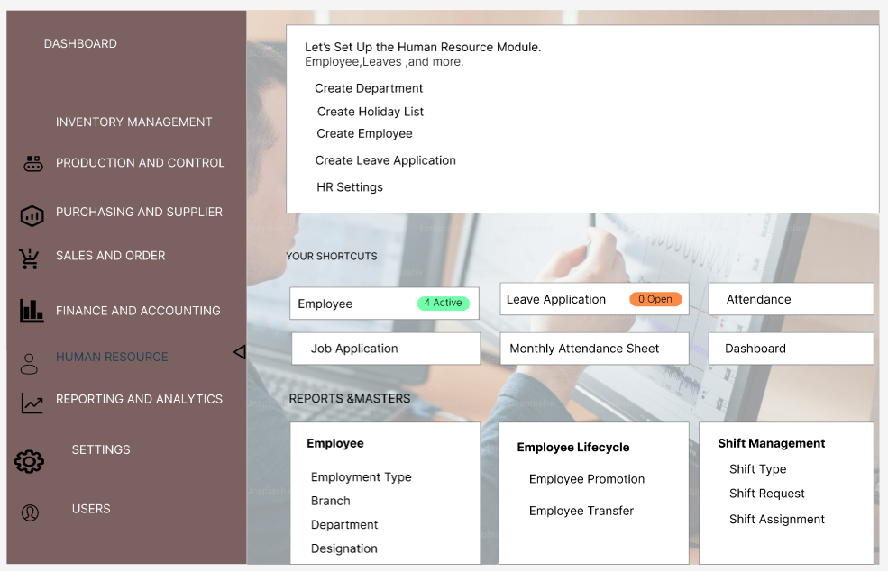

**Key Functionalities:**

Employee Records: Store personal details, employment history, and contract information for all employees.

Attendance and Payroll: Track employee attendance and automate payroll calculations.

Performance Management: Record performance reviews and set goals for employees.

Document Generation: Automatically create pay slips, contracts, and performance evaluation reports.

* 1. **Reporting and Analytics**

The Reporting and Analytics module generates insights and visualizes key performance indicators (KPI).

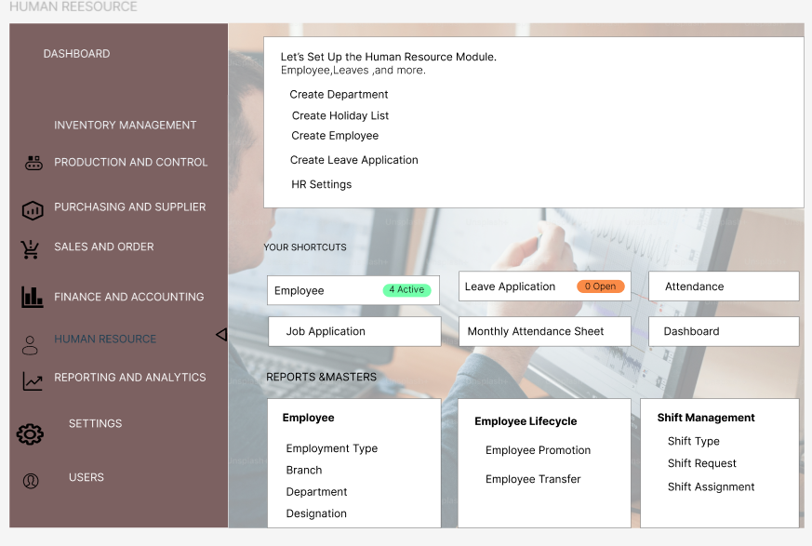

**Key Functionalities:**

Data Visualization: Use charts, graphs, and tables to present real-time insights and trends across all modules.

Custom Reports: Allow users to create custom reports based on specified parameters.

Export Options: Allow users to export reports to various formats such as PDF, Excel, etc. and schedule automatic report generation.

Integration with Tableau: Visualize data using Tableau for in-depth analytics and trend analysis.

1. **Security Architecture**

Role-Based Access Control (RBAC): Access to the system is restricted based on user roles (e.g., admin, manager, employee).

Data Encryption: All sensitive data, including financial transactions and personal employee information, is encrypted both at rest and in transit.

Authentication: Two-factor authentication (2FA) and secure login procedures are implemented.

**5. Scalability and Integration**

Modular Design: Each module can be updated or expanded independently to accommodate future growth.

APIs for Integration: Provide APIs for integrating with third-party systems like accounting software or supply chain management tools.

**6. User Interface Design**

Responsive UI: The system is accessible across devices (desktop, tablet, mobile) with a consistent user experience.

Intuitive Navigation: Each module features intuitive menus, search functions, and filter options for ease of use.

Dashboard Customization: Users can customize their dashboards to display the KPIs and reports most relevant to their roles.

**7. Database Design**

Relational Database: The system uses a normalized relational database with tables designed for each module (e.g., inventory, production, sales, HR).

ERD: Entity-Relationship Diagrams depict the relationships between different data entities across modules.

Data Integrity: Referential integrity is enforced through foreign key constraints to maintain data consistency.

**8. Implementation**

**8.1 Deployment Phases**

* **Phase 1: Planning**

1. Conduct meetings to identify key requirements, goals and timelines.
2. Ensure all hardware and software are ready and change management plan are created to help employees transition smoothly.

* **Phase 2: System installation and Configuration**

1. Install the ERP system on servers.
2. Configure the system setting according to department specific needs, role-based access controls and authentication systems.

* **Phase 3: Data Migration**

1. Transfer existing data into the ERP system and ensure backup copies are stored securely.
2. Perform checks to verify data integrity and accuracy after migration

* **Phase 4: Testing**

1. Conduct a comprehensive testing such as unit testing, integration testing and user acceptance testing.
2. Fix error or bugs that are identified during testing.

* **Phase 5: Go Live**

1. Launch the ERP system entirely for day-to-day operations.
2. Monitor the system for performance issues, user challenges and bugs to be quickly addressed.

* **Phase 6: Post-Implementation support**

1. Provide support after full deployment to ensure stability and user satisfaction.

**8.2 Training Plan**

Strategies:

* Workshops and Simulations: Conduct workshops where employees work through real-life scenarios using the ERP system.
* Online Training Portal: Provide access to self-paced video tutorials and how-to guides.
* Role-Based Training: Tailor training materials to specific roles (e.g., warehouse staff, production managers, HR personnel) to ensure relevance.

**8.3 Support and Maintenance**

Strategies:

* On-Site IT Staff: Have technical staff on-site during the initial post-deployment phase to address issues quickly.
* Help-desk Support: Set up a dedicated help desk with extended hours for users to support users.
* Regular Updates: Implement system updates and patches to improve functionality and security.
* User Feedback Integration: Continuously collect and analyze user feedback to inform future updates and enhancements.

**8.4 Risk Management**

Strategies:

* Data Loss Prevention: Conduct data backups before migration and validate data at each stage.
* Downtime Management: Implement a rollback plan in case of critical system failure during go-live.
* Change Management: Implement strong change management and training plans to alleviate user resistance.

**9. Conclusion**

This ERP system design is developed to address the mini manufacturing company's operational needs, ensuring seamless integration of key business processes, scalability, and a user-friendly experience. This detailed documentation serves as the foundation for system development and future upgrades.